**Test Scenario: Instructions:**

This test scenario verifies that the user can view the instructions for selecting their skin type and understanding the application's functionalities.

Click the "Read Me!" button and to verify that the instructions for picking a skin type are displayed correctly.

**Selecting Skin Types and Viewing Products:**

I’ve selected each skin type (Dry, Oily, Combination, Sensitive) and verified that the corresponding products and descriptions are displayed correctly.

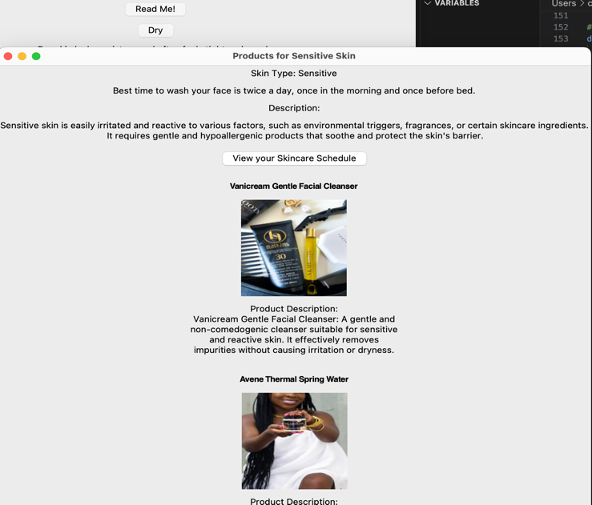

**Test Scenario: View Skincare Schedule:**

Clicked on the "View your Skincare Schedule" button and verified that the skincare schedule and best times to wash face are displayed correctly.

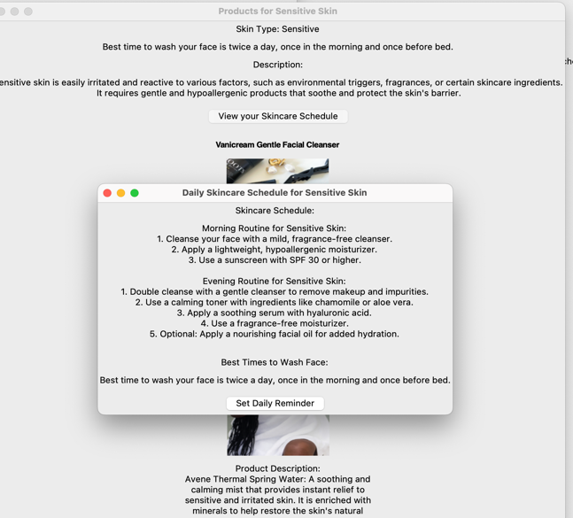

**Test Scenario: Set Daily Reminder”**

For each skin type, I click on the "Set Daily Reminder" button, to ensure that the "Set Daily Reminder" window appears.

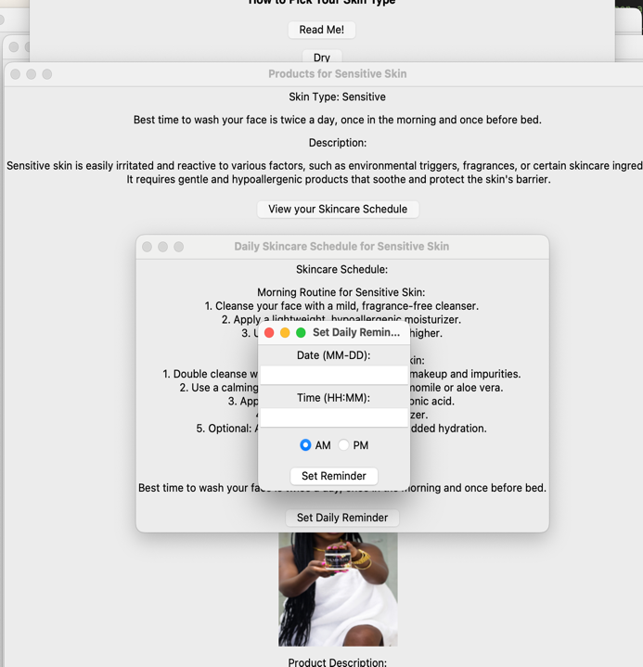

**Test Scenario: "Appointment Time Has Passed" Window**

**Description:**

This test scenario verifies that when the user sets a daily reminder with an appointment time that has already passed, a confirmation window appears asking the user if they want to reschedule for tomorrow or the day after.

**Test Scenario: "Set Daily Reminder “Conformation Window**

**Description:**

This test scenario verifies that customers see a confirmation window when setting a daily reminder through the application. The confirmation window provides options for the user to proceed with setting the reminder or cancel the operation.**Screens screenshot of a screenshot of a screenshot of a screenshot of a screenshot of a screenshot of a screenshot of a screenshot of a screenshot of a screenshot
**

**Test Scenario: Closing the "Incorrect Input" Window**

**Description:**

This test scenario verifies that the "Incorrect Input" window, which appears when the user enters invalid date or time formats while setting the daily reminder, can be closed properly by the user.

**Test Scenario: Exiting the Application**

**Description:** This test scenario verifies that the user can exit the application safely and confirms that the user is prompted with a confirmation window before the application is closed.

Clicked the "Exit" button to verify that a confirmation dialog appears.

Clicked "Yes" on the confirmation dialog to ensure that the application closes.

**Testings:**

